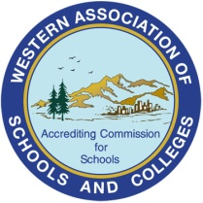
Marilyn S. George, Ed.D.
Vice President

Accrediting Commission for Schools
Western Association of Schools and Colleges
533 Airport Boulevard, Suite 200 • Burlingame, California 94010
(650) 696-1060 • Fax (650) 696-1867
mail@acswasc.org • www.acswasc.org
Fred Van Leuven, Ed.D.
President

ACS WASC CREDIT CARD PAYMENT
AUTHORIZATION FORM
In order to pay by credit card please provide the following information. It is important that you include all of the requested information so that we can properly apply the payment to your school’s account.

I authorize ACS WASC to charge $ _ (amount in U.S. dollars) to the following credit card account:
Credit Card Number:
Expiration Date (MM/YY):
Security Code (the three-digit number on the back of the credit card*):
*Four digit number on the front of American Express cards.
Invoice Number:
School Name:
Bill Description:
Credit Card Billing Address
Company Name:
Last Name:
First Name:
Address 1:
Address 2:
City:
State/Province:
Postal Code:
Country:
Phone:
Email address:

Signature: |  |  | Date:

Please contact Mr. Albert Chan, 650 548-4376 or achan@acswasc.org with any questions.
Thank you,
Accrediting Commission for Schools, WASC

