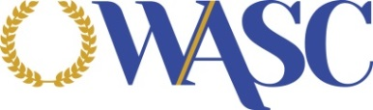
Accrediting Commission for Schools
Western Association of Schools and Colleges

ACS WASC DIRECTORY OF SCHOOLS
The Accrediting Commission for Schools, Western Association of Schools and Colleges publishes an annual directory of schools. The directory provides information about the schools currently accredited by ACS WASC and those schools that have been granted the status of candidacy. To order a copy of the publication, please fill out the attached form and mail it to the ACS WASC office along with your check or purchase order information. We also accept PayPal, if you would like to pay using PayPal provide your email address below and we will send you a PayPal invoice. Please contact the ACS WASC office at 650 696-1060 if you have any questions.

ACS WASC Directory of Schools Order
ITEM | PRICE* | QTY. | TOTAL AMOUNT
ACS WASC Directory of Schools | $15.00 |  | $
TOTAL AMOUNT DUE |  |  | $
*Price includes tax, shipping and handling within the United States. Additional shipping fees will apply for orders shipped outside of the United States.

School/Institution Name:
Attention:
Address:
Shipping Address and Attention (if different)
Purchase Order Number
(if applicable):
PayPal Payment Email:
Mail completed order form and check to:
Accrediting Commission for Schools, WASC
Attn: Mr. Lino Gantan
533 Airport Boulevard, Suite 200
Burlingame, CA 94010
lgantan@acswasc.org

Note: Purchase orders or checks sent without a completed order form will not be processed and will be returned to the sender.

